**Data for the model – Written part**

**The main idea of the thesis**

* Placement of EV chargers
  + Not only for efficiency and effectiveness within the city but also due to lack of viable business models for building up charging infrastructure that mostly relies on state or other type of subsidies
* The main idea is to find suitable locations for the next chargers to be build
  + In areas where there is the most demand that is not covered by existing chargers. Therefore, maximizing the revenue of the new station as an incentive for the investor to build the charger
* Business model
  + = Chicken Egg problem – problem of chargers and viable business models, no incentives for private sectors
    - Can be seen on who owns the current EV chargers (mostly Electricity suppliers who have reduced cost)
    - Hence the model is profit maximizing to have real life applicability
* Degree of novelty
  + This optimization problem has been conducted in various ways across different cities in Europe
  + My problem is based on methods adopted in studies conducted in Västerås, Sweden and Manchester, United Kingdom
  + I will construct a similar study for Prague, Czech Republic and further add an analysis regarding consumer perception and its resistance to change, EV charger business model, paradigm shift in the propulsion systems of personal mobility vehicles including the influence of EU directives on the industry and future of personal mobility in Czech Republic

**Problem definition**

* Create a function that produces sets for demand locations (centre points of the grid cells) and the potential EV charging locations, taking existing chargers into consideration
* Distance matrix will be used to generate the concept of the service area, if the distance between the demand centroid and car park is greater than 1km
  + Willing walking distance
  + Distance matrix function
* Create a function that contains all the parameters and a function that contains the demand currently met by the existing EV charging stations in each grid cell i
  + Demand = proportion of EVs among current cars
* Objective function = Mixed integer linear problem
* Aim: Maximize profits of the charging station
  + Constraints = ensure cars charged at a station are less than the capacity of the station and the charging demand + guarantee demands in grid cell “i” are in the service area of the station

**Information and data to work with**

For optimization problem

* Traffic Flow
  + I have data of 700+ junctions that was recorded and averaged over working days of 2021
* Existing chargers
  + The data is collected from an up-to-date charging point map (nearly done)
* Car park location -> potential place for a new charging station
  + Car parks locations have to be extracted from a map (have to do)
* Land classification
  + According to the grid map – Natural, Residential, Mixed use, Other

Grid map

* Area of 150-200 km2, with grid size of 1km2
  + Grids are the potential areas for new charging stations
* Have to be created in ArcGis
  + <https://www.arcgis.com/index.html>
  + The coordinates of the grids have to be collected
    - Matching the traffic points, existing chargers and car park locations to these grids

For theoretical discussion

* Other points of interest (shopping malls, etc.)
* Analysis of the particular area and real-life suitability

**Objective function**

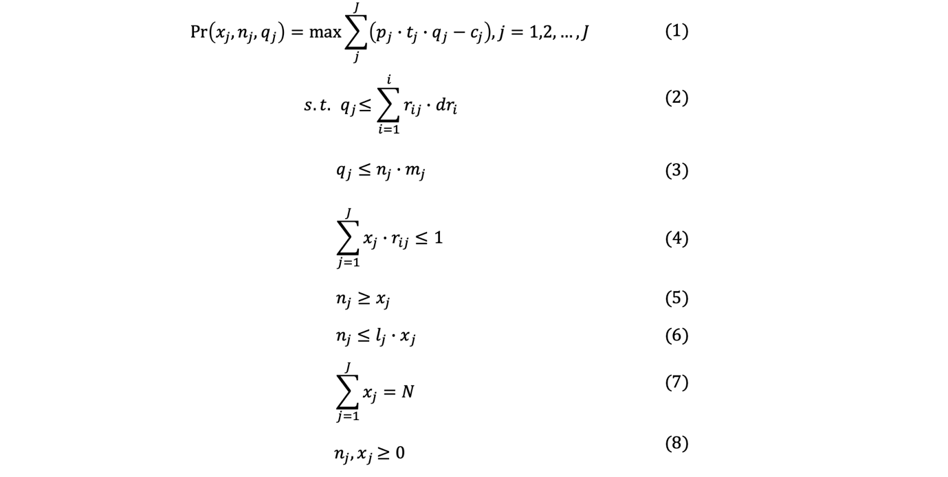

Probability of (carpark being selected; number of chargers in a station; number of cars charged by a station) = max sum of (cost of charging per minute * charging time for an EV * number of cars charged by station – total cost of station)

Subject to:

It is assumed that each charger is possible to charge 𝑚 cars at most per day, and constraint (2) and (3) make sure that the cars charged in the station are less than both the capacity of the station and the charging demand.

Constraint (4) ensures that the remaining charging demand in grid 𝑖 are in the service area of only one station, which ensures that different demand nodes are distributed to different charging stations.

Formula (5) and (6) ensure that each station would have at least one charger and at most 𝑙𝑗 chargers, this can be determined according to the constraints at different points in the power grid. Moreover, the constraints also have the logical implication for example if there is no station, there is no charger and vice versa.

Also, a company may have a maximum budget allocated to placing charging stations, so at most N stations would be placed in the city according to formula (7). Constraint (8) ensures all the decision variables are integers and non-negative.

**Supporting equations**

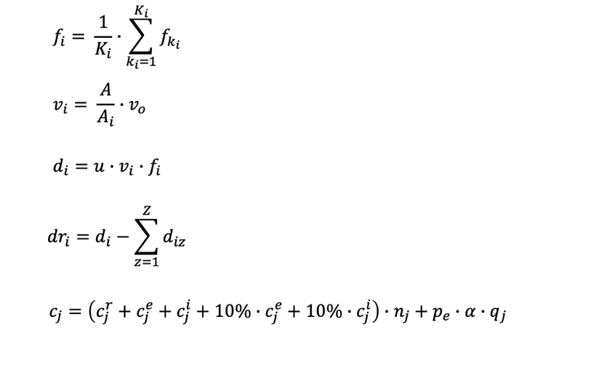

Average traffic flow (fi)

= 1 / number of junctions * sum (daily traffic flow in a junction)

Charging possibility of an EV in a cell (vi)

= (Area of the cell / Sum of mixed-use area in the cell) * charging possibility of an EV in cell

Charging demand (di)

= EV penetration rate 0,1 * charging possibility of an EV in cell * average traffic flow in cell

Charging demand in grid cell (dri)

= charging demand – sum (charging demand of an EV in grid cell I already being met by existing station)

Total cost of the charging station (cj)

= (parking fee per day + price of the charger + installation cost + 0,1 * price of the charger + 0,1 * installation cost) * number of chargers in station + price of electricity * average battery capacity * number of cars charged by station

**Next steps for me to do**

* Finish the data processing
  + Current EV chargers’ locations
  + Coordinates of the junctions and its integration to the grid map
  + Extract coordinates of the car parks
* Create a grid map and identify the individual grid cells
  + Integrate this with the traffic data and locations of the existing chargers and car parks
* Organize sources of information for the theory/background information part
* Upload the processed data to GitHub
* Create a working model and test it

**Additional Data for the model**

Source: <https://www.tsk-praha.cz/wps/wcm/connect/www.tsk-praha.cz20642/5cd6db01-4808-4dce-9c50-2086e40fb918/mapa-praha.pdf?MOD=AJPERES&attachment=true&id=1651152033667>



**Usable area - roughly**

Coordinates:

* 50.12748556802395,14.310085522839552
* 50.042010210543715,14.30767639915317
* 50.042010210543715,14.533582771223482
* 50.12792458614414,14.52705963889926

Area used for the problem, roughly 150km2

* To be exactly estimated by ArcGis/other grid map software
* Aim to create around 150-200 grid areas (1km2 each) which will be the subject to the optimization and prediction of the charging stations

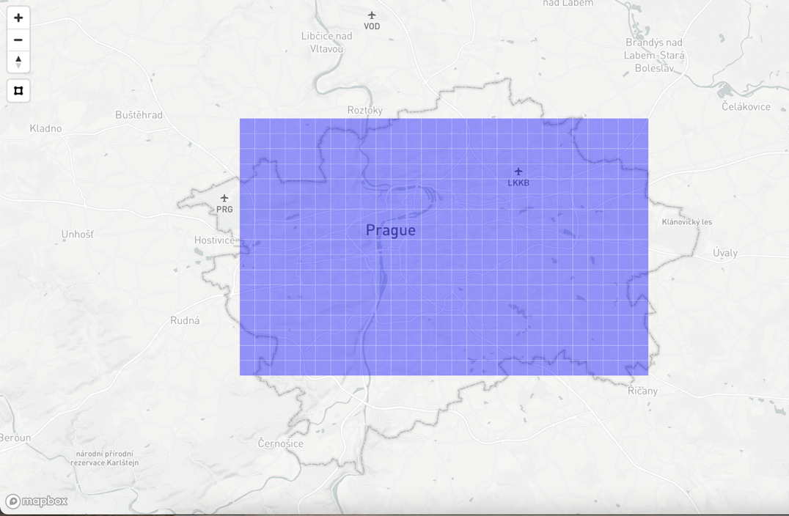

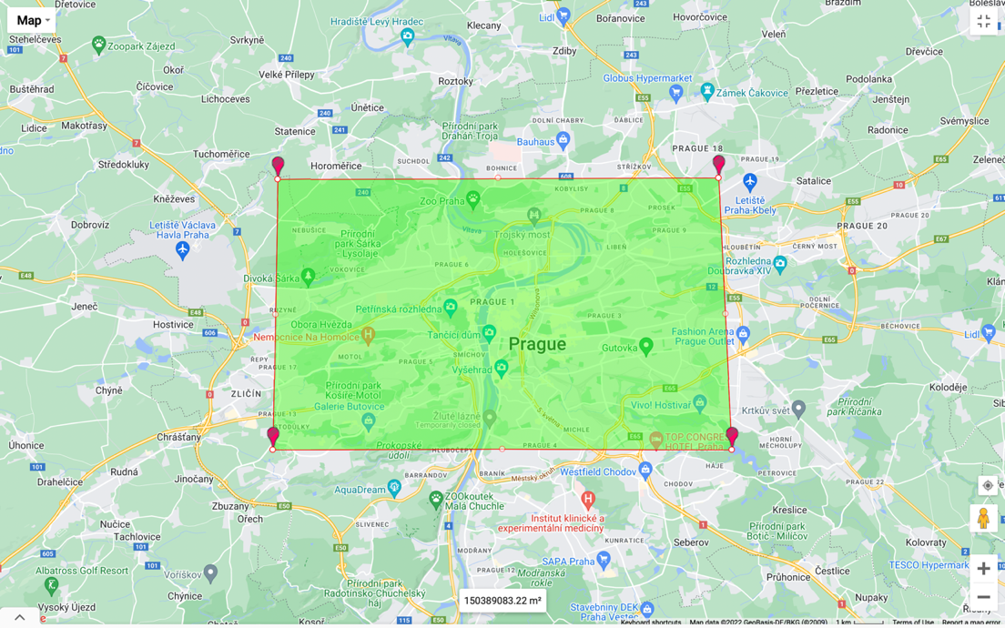

**Estimating demand for charging**

1 217 344 cars in Prague

6 290 000 cars in Czech Republic

4779 EVs in Prague

12 325 EVs in Czech Republic

Sources:

* <https://www.ekovozy.cz>
* <https://cesky.radio.cz/pocet-osobnich-aut-v-cesku-loni-stoupl-o-vice-nez-163-tisic-na-629-milionu-8740092>
* <https://www.idnes.cz/auto/zpravodajstvi/praha-statistika-auta.A220826_093503_automoto_fdv>

**Estimating battery capacity of EVs in Prague**

Most frequently registered EVs

* Škoda Enyaq iV (782)
* Hyundai Kona EV (97)
* Kia EV6 (76)
* Volkswagen ID.4 (65)
* Tesla Model Y (61)
* Hyundai IONIQ 5 (55)

Their average battery capacity

* Škoda Enyaq iV – 82 KWh
* Hyundai Kona EV – 64 KWh
* Kia EV6 – 77,4 KWh
* Volkswagen ID.4 - 52 KWh
* Tesla Model Y – 75 KWh
* Hyundai IONIQ 5 – 58 KWh

Average capacity = 68 KWh

**Car parks**

* Zones for residents, along the streets, not suitable for building a charging station
* Looking for existing car parks of a larger scale that can accommodate the chargers
* Extracting from the up to date map of commercial parking lots in Prague

**Average charging points in a charging station**

1417/744

* Approx. 2 charging points per station
* Will be assumed for the model
* Exact number of charging points for each station is not in the database

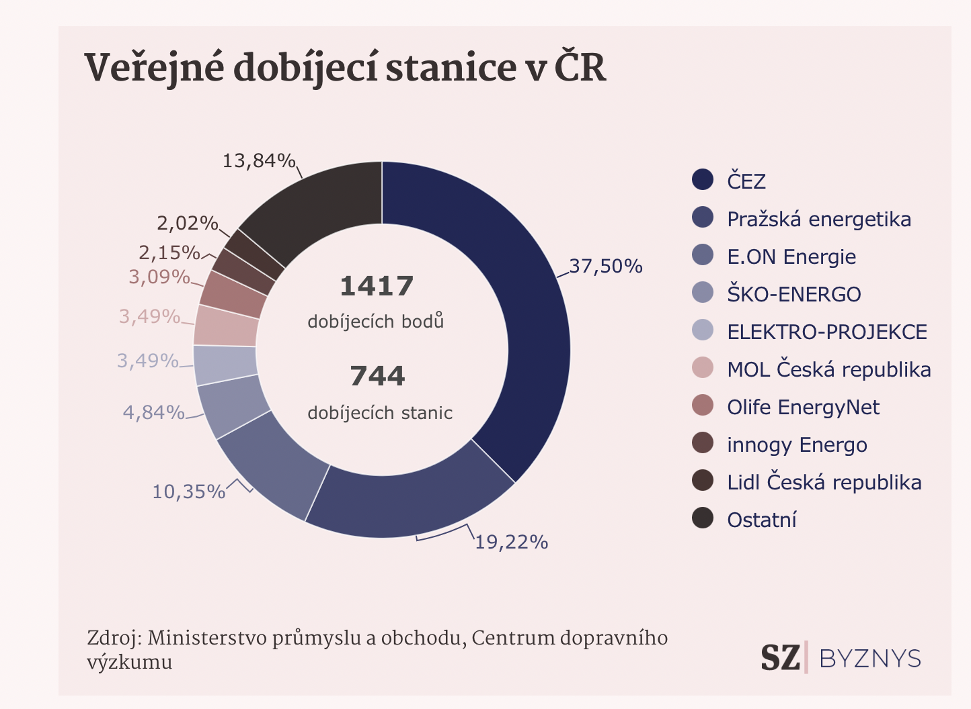

Source:

* <https://www.seznamzpravy.cz/clanek/firmy-stavi-nabijecky-za-sve-do-domacich-garazi-je-zaplati-stat-174192>

**Cost of charging station**

<https://wattlogic.com/blog/commercial-ev-charging-stations-cost/>

<https://afdc.energy.gov/files/u/publication/evse_cost_report_2015.pdf>

<https://futureenergy.com/how-much-do-ev-charging-stations-cost/>

Highly variable cost – need to find a reference point and justify the use of the cost, describe that factors that make this statistic vary

To meet the demands of all potential buyers, it is necessary to grow the charging network wisely.

**Types of chargers**

To be added